DT10 Desktop Ticket Machine
(Non-Networked Version)

Hardware & Software Installation Guide
(DT10 V3.03 & CEW V1.02)

Directional Data Systems Ltd

Table Of Contents
1 Overview 3
2 Deliverables 3
3 DT10 Setup 4
4 Cashdrawer Setup 6
5 Customer Display Setup 7
6 Slave Ticket Printer Setup (4” Blaster) 8
7 Slave Ticket Printer Setup (2” Wristbands) 8
8 Price Plugs 8
8.1 Operator Price Plug (OPP - Yellow) 8
8.2 Manager Price Plug (MPP - Red) 8
8.3 Programmer Price Plug (PPP - Blue) 8
9 Configuration Editor Software 9
9.1 Installation 9
9.2 Using the Software 11
9.3 Programming the Priceplugs 12

1 Overview

The purpose of this manual is to guide you through the various installation and set up options available with the DT10 desktop ticket machine.

This guide is valid for both new installations and upgrades of the DT10 from V2x to 3x and the Configuration Editor software from MS-DOS to Windows.

2 Deliverables

You will have received one or more of the following:

DT10:
DT10 Ticket Machine
Paper holder wire
Plastic paper lid
Power block
Power cable

Cashdrawer:
Key
Fixed cable

Customer Display:
Parts & assembly as shown in boxed document

A 4 Inch Slave Ticket Printer:
Perspex paper holder & guide
Plastic lid
DT10 to slave data cable
Power block
Power cable

A 2 Inch Slave Wristband Printer:
Wristband stock holder and guide
DT10 to slave data cable
Power block
Power cable

Operator Price Plug (yellow)

Manager Price Plugs (red)

Programmer Price Plugs (blue)

Configuration Editor software on CD

DT10 to PC Data Cables (8 pin)

DT10 Reporting Software on CD

The external appearance of the parts listed above may differ to those used in the production of this manual.

3 DT10 Setup

Remove from packaging. Plug the power block small connector into the base of the DT10.

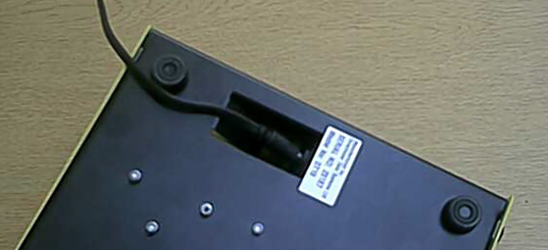

Now attach the power cable to the DT10 power block and to a mains outlet.

Open a roll of DT10 ticket stock and remove the first few sheets to give a clean straight perforated edge. Feed the first sheet up the paper chute within the ticket stock cavity as far as it will go.

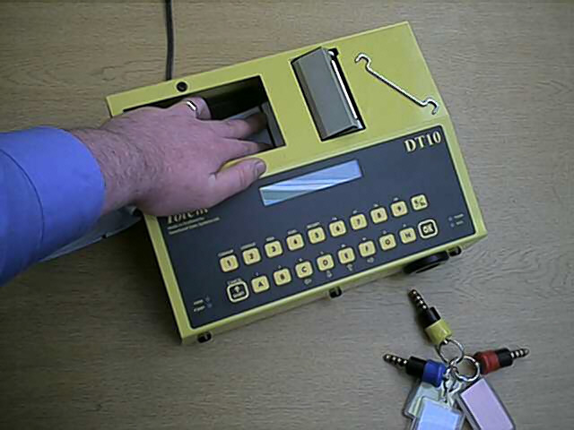

Keeping the paper flat and with a slight forward pressure, place a red or yellow Price Plug into the socket on the front of the DT10.

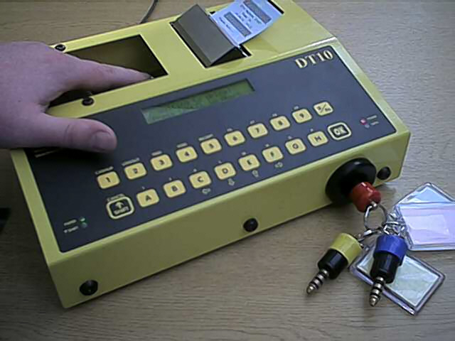

The DT10 will power up and attempt to feed the ticket stock.

Trial and error will show you how to perfect and make easy the loading of ticket stock.

Once the ticket stock has loaded correctly, power down the DT10 by removing the Price Plug. If you have purchased the data uploadable version of the DT10 (for reporting purposes), press cancel at the ‘waiting to upload’ prompt before or after removing the Price Plug.

If you require to load fresh ticket stock whilst the DT10 is in use, pressing Function (0/Fn) then Feed (3) should be performed in place of the Price Plug insertion described above. The LCD will display ‘Auto Paper Loading’ for 3 seconds before attempting to feed the ticket stock.

Once the ticket stock has loaded, place the roll onto the supplied wire holder, and place the wire into the two black rubber holes either side of the ticket stock cavity. Finally, place the black plastic lid over the ticket stock.

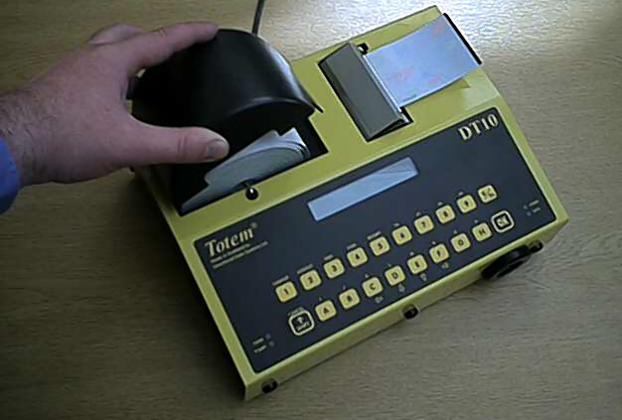

4 Cashdrawer Setup

The cash drawer should be unpacked and it’s cable attached to the Cashdrawer port (A) on the DT10.

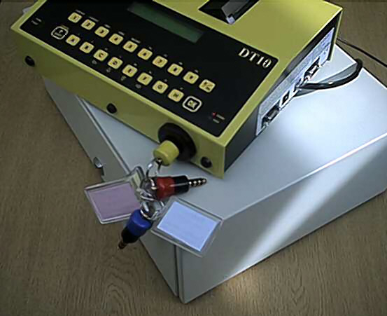
A

Always place the cashdrawer on a solid surface as the auto opening action can alter its centre of gravity quite considerably.

Please refer to the Configuration Editor on-line help or contact your vendor for details on the different ways the cashdrawer can be operated.

5 Customer Display Setup

Unpack the customer display.

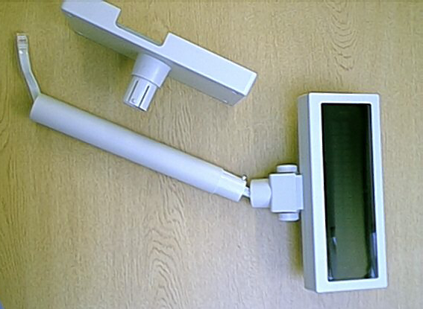

The display cable should be fed through the selected height of neck and into the base.

The display cable should then be inserted to the Display socket (A).

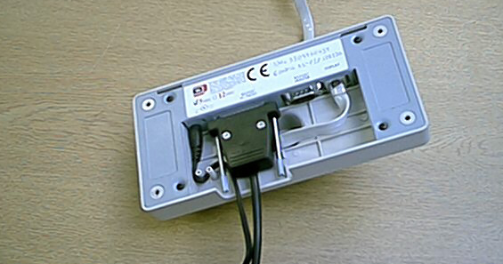
A
B
D
C

The Customer Display to DT10 Cable should be connected to socket B, and the power cable to socket C. The power cable should be wrapped around the two pins D to avoid accidental disconnection.

The Customer Display should then be connected to DT10 port 2.

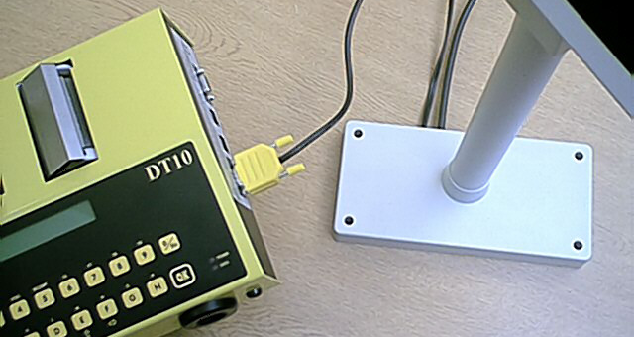

The dip-switch settings of your customer display (on the base of the display head) will have been set by your vendor prior to shipping. Do not change these settings unless advised to do so by your vendor.

6 Slave Ticket Printer Setup (4” Blaster)

To follow

7 Slave Ticket Printer Setup (2” Wristbands)

To follow

8 Price Plugs

8.1 Operator Price Plug (OPP - Yellow)

The OPP(s) contain information (a Configuration) regarding the tickets you wish to print. The Ticket Type text (Adult, Child, Car etc), ticket prices, ticket layout are all contained within the OPP. When the OPP is inserted to the DT10 ticket machine, the machine reads this information and is then enabled to print those tickets.

The OPP(s) supplied to you should have a configuration already programmed into them, and, if you wish to edit your own configurations (using the Configuration Editor for Windows software - CEW) rather than return the OPP(s) to your vendor for occasional reconfiguration, the configuration file used to program the OPP(s) should also have been supplied to you by your vendor.

If you wish to edit your own Ticket Types or if you wish to create reports based upon DT10 ticket sales, you must first obtain and install the CEW software.

For full details of the options available to the OPP(s), refer to the on-line help of the CEW software or consult your vendor.

8.2 Manager Price Plug (MPP - Red)

The MPP(s) contain information on how the DT10 ticket machine should function. Settings to allow or disallow receipt printing, ticket voiding and cashing out are all contained within the MPP, as well as tax reference numbers, currency strings, cashdrawer & customer display settings and slave printer settings.

When inserted to the DT10, the MPP also allows some manager functions to be performed. Setting of date & time, printing of spot-checks & audit-trails and cashing out of operators’ shifts are some of the items available from the manager functions.

For full details of the options available to the MPP(s), refer to the on-line help of the CEW software or consult your vendor.

8.3 Programmer Price Plug (PPP - Blue)

The PPP(s) contain no data as such. The PPP(s) simply acts as a ‘security key’ to allow the programming of the OPP(s) and MPP(s).

When inserted into the DT10 ticket machine, the machine powers up into Priceplug Program Mode, and will stay in this mode until the Cancel key is pressed.

The PPP can then be removed from the DT10 and the OPP(s) and/or MPP(s) then inserted and programmed using the CEW software.

9 Configuration Editor Software

9.1 Installation

You may have been supplied with software (Configuration Editor for Windows - CEW) that allows you to change the data and settings contained on your Price Plugs as described above. You will also have been supplied with a DT10 to PC data cable. The cable will have an 8 pin male connector at one end. It is important that you use only this cable (with pin 9 removed) to perform DT10 to PC & PC to DT10 data transfer.

The software has full on-line help, and the following should act only as a quick guide.

To install CEW Place the supplied CD into your CD-ROM drive (assuming d:)

To install the DT10 Configuration software, run d:\Install Files\Setup.exe.

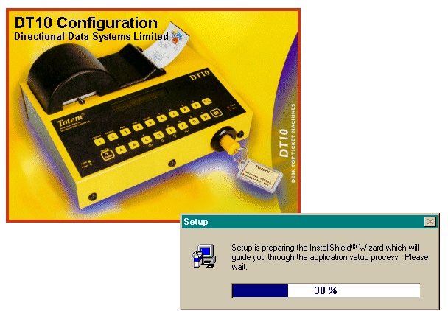

Follow the on-screen instructions, selecting all default options.

The configuration currently programmed into your plugs may be on the CD (in directory d:\Configuration), or will be supplied to you separately by your vendor. This configuration, a file named *.dtc, should be copied to the directory c:\Program Files\DT10 Configuration.

The software is now ready to run.

Run the software by selecting the DT10 Configuration icon that was created on your desktop during installation.

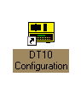

The following screen will appear.

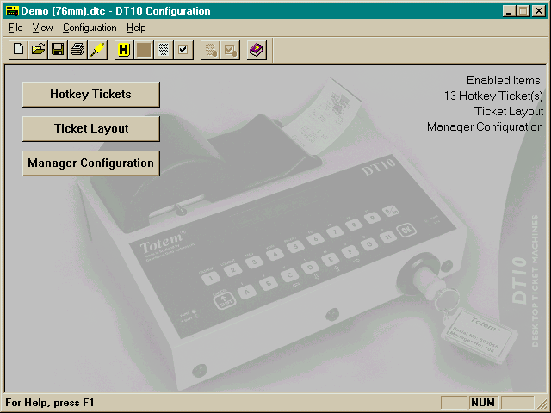

To load the configuration that is currently in your plugs (ABC2002.dtc for this example), select File/Open and the following dialogue box will appear.

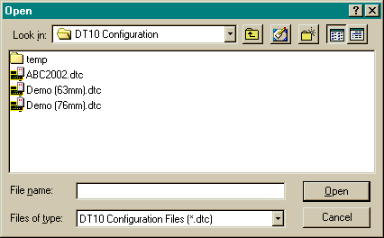

To load the configuration, highlight the file ABC2002.dtc and click Open, or simply double click the required file. The loaded file is always printed at the top left of the CEW window.

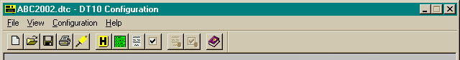

9.2 Using the Software

Please refer to the on-line help, for details of how to make changes to the configuration and how those changes will affect the functionality of your DT10 ticket machine.

If you wish to view reports based upon DT10 ticket Sales, it is important that File/Program Preferences/ Configuration tab is set as shown below, and that you File/Save & Publish any changes that you wish to program into your priceplugs.

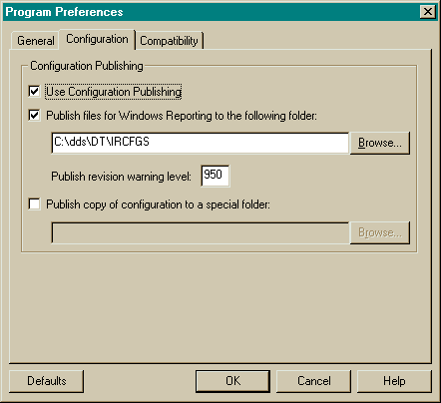

9.3 Programming the Priceplugs

Once you have edited and your Configuration as required, you must then select File/Save (or File/Save & Publish for installations to work with Reporting) if you wish to keep the configuration name (ABC2002.dtc) the same, or File/ Save As to give a new name to your edited configuration (ABC2003.dtc in the example below).

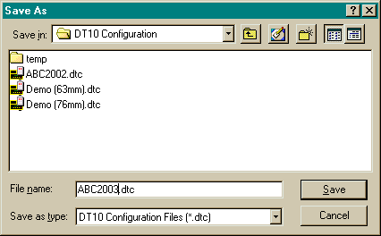

File/Save As should always be followed by File/Save & Publish for installations to work with Reporting.

You are now ready to program the priceplugs with your new configuration.

First, place the DT10 ticket machine into Priceplug Program Mode by powering it up with the PPP (blue priceplug), then remove the PPP.

Connect the 8pin connector to Port 2 of the DT10 (removing any other peripheral cables that may be there already).

Connect the female end of the cable to a serial port on your PC or laptop. The serial port that you are using to connect to the DT10 should be specified in the File/Program Preferences/General tab as below.

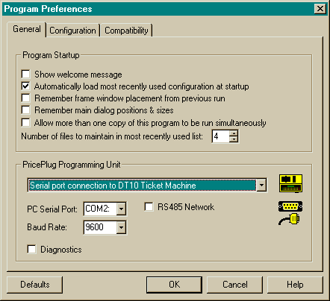
Now place the OPP(s) (yellow) and/or MPP(s) (red), one at a time, into the DT10, depending on what changes you made to your configuration.

Select File/PricePlug Programming or the OPP icon, and the following screen will appear.

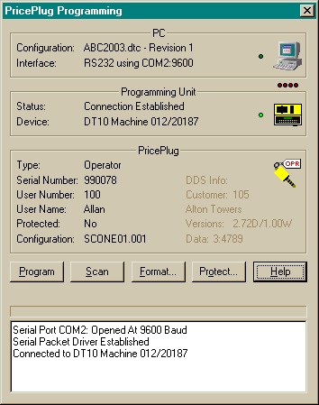

To program the plug select Program.

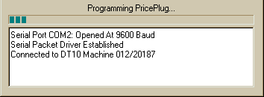

OPPs will take approximately one minute to program – MPPs will be quicker.

Once all Yellow and/or Red plugs are programmed, press cancel on the DT10 to power it down.

To place the new MPP settings into the DT10, insert an MPP into the ticket machine and then remove it.

To begin printing tickets with the new configuration, insert the OPP into the DT10 and begin selling tickets.

For detail on the operational functions available to the DT10, please refer to the Operator and/or Manager manuals (yellow and pink laminated sheets) supplied by your vendor.

